For one-to-one feature-target correlations I either used one-way ANOVA or a chi-squared test + Cramer’s V test to determine how relevant each variable was to the target (depending on whether the feature was continuous or categorical). Cramer’s V works similarly to Pearson’s correlation – the values don’t correspond from one test to the other, but both determine how closely associated two variables are to one another. One-way ANOVA does not directly answer the question of correlations but instead determines whether there is an association between variables.
Because the target variable was categorical, I then used multinomial logistic regression instead of multiple linear regression for multivariate correlations and predictions. I first one-hot encoded my categorical variables and combined infrequent values into an “Other category.” This still significantly expanded the number of features to 3000. I tried using PCA (this took a long time to run), but it required many PCs (50) and had a slightly lower accuracy (77%) (3 PCs had an accuracy of 48%) than just throwing all the features into the model (78%). PCA is also harder to interpret when answering the question of “which predictors have the most impact on the target variable” as each PC is made of a mix of the predictors. I then printed out the 10 most impactful features for each target outcome. The predictors make sense for each outcome.
One-hot encoding leads to highly sparse datasets, so I don’t think the logistic regression method would scale.
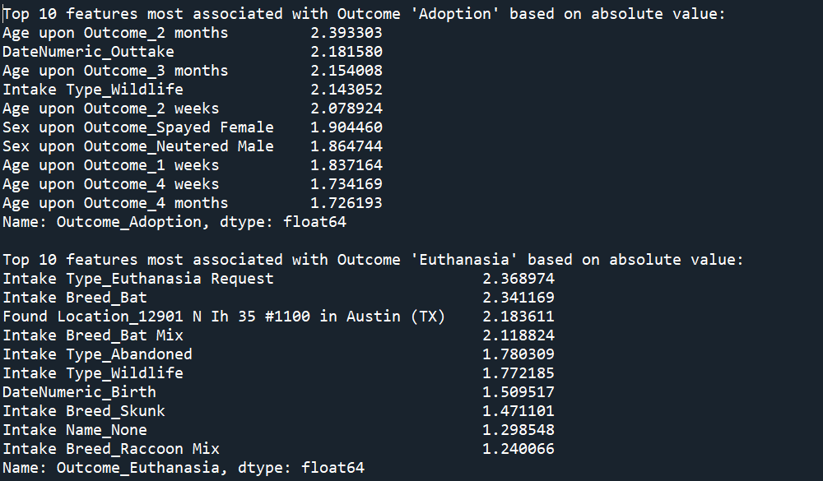
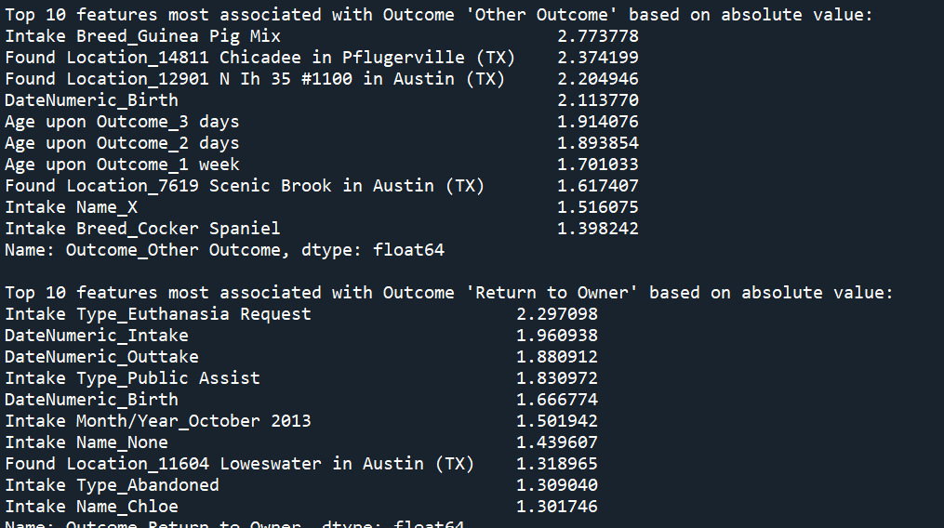
Next, I tried CatBoost, a tree-based model that automatically handles categorical variables. (Also has a regression version for a continuous target variable: CatBoostRegressor.) I could just throw in my merged dataset and it returned the features in order of importance to the prediction. (I included Animal ID but it could easily have been discarded due to its lack of correlation in previous tests.)
The features here are obviously not as granular as in the previous model due to the lack of one-hot encoding (and are also not separated by outcome category) but appear to generally track with the results of Logistic Regression. This model is 80% accurate without any hyperparameter tuning etc.
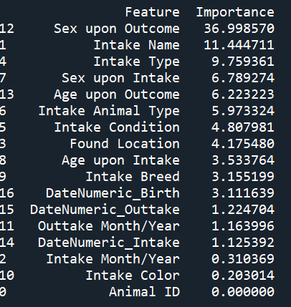
Breaking it down by class…
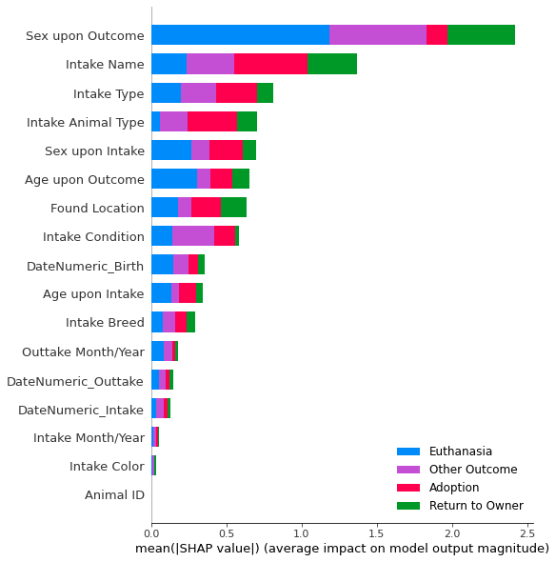
The most important features are not identical across the two models, but I assume that is due to the feature coding in the Logistic Regression model (adding an “Other category” for each categorical variable). Classes are Adoption (0), Euthanasia (1), Other (2), Return to Owner (3).
Then I added indirect variables and ran the chi-squared tests and CatBoost model again.
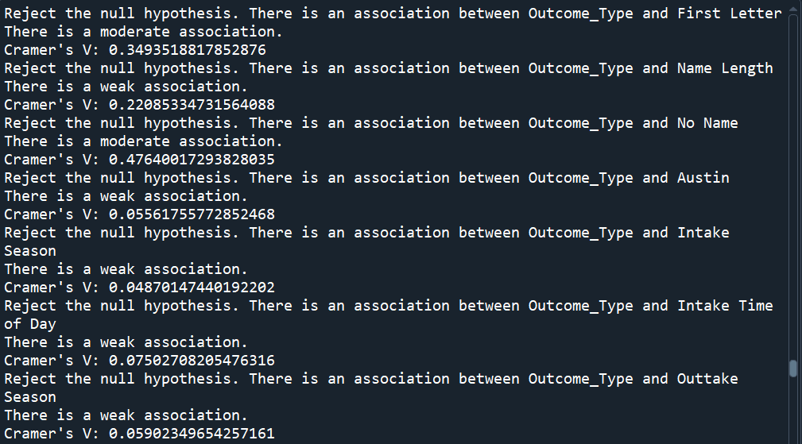
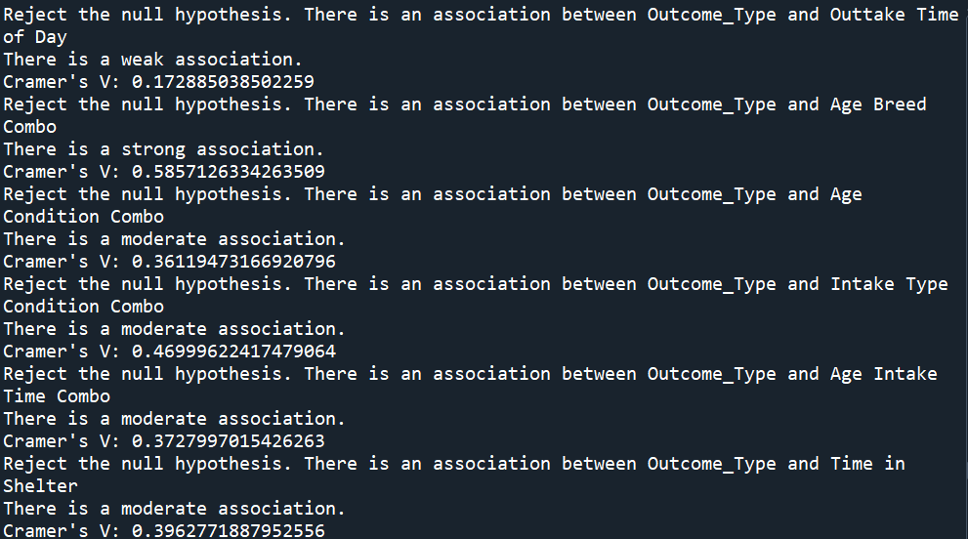
Typically, weak associations do not have strong feature importance. Moderate to strong associations will have medium to high feature importance, but this does not always correspond to the strength of the individual assocations.
Most important indirect features: time in shelter, first letter, intake type and intake condition combination, outtake time of day, age and breed combination, whether an animal has a name or not. This is a mix between GPT’s ideas for variables and mine.
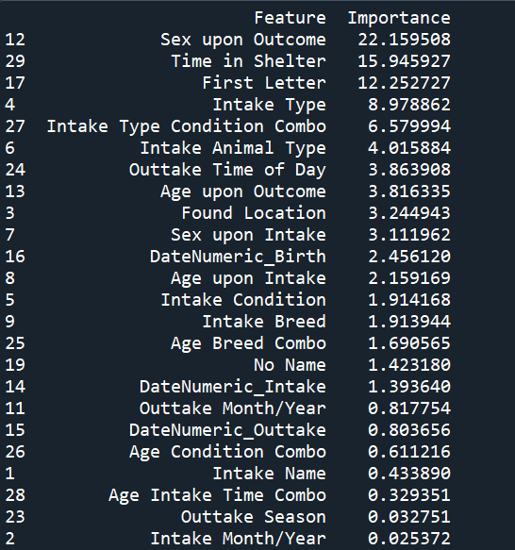
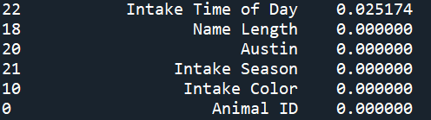
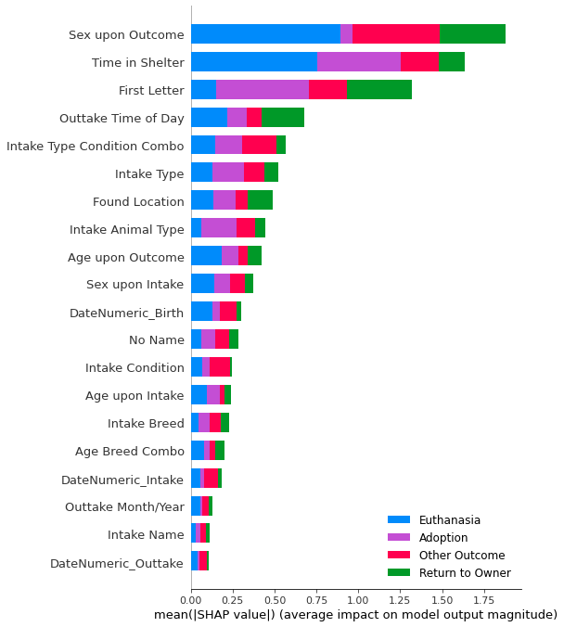
You could further refine the model by only using a certain number of features or eliminating features with no importance and then re-running predictions.
My research also says that collinearity may affect the overall feature importance: the importance of a feature might be reduced when other collinear features are present in the model. The model’s accuracy is not affected by collinearity, though. I didn’t explicitly look for collinearity but that also could be something to take into account.

SHAP:
- Deconstructs prediction into sum of contributions from each input variable
- Quantifies how important each input variable is to a model for making predictions
  - Checks that the model is behaving in a reasonable way
  - Can serve as a diagnostic tool or a mechanism for hypothesis generation
- Only tells you what model is doing w/in context of training data
- Bar plots: shows the mean absolute SHAP value, features with higher mean absolute SHAP values are more influential, relate to which features impact predictions most as opposed to conventional feature importance metrics
- Beeswarm plots: break down feature importance for each outcome category
Multiple regression with categorical predictor variables:
- One-hot encode variables and then use in regression analysis
- Other encodings are possible but may lead to more complicated interpretations of results
- Dichotomous variables can be directly translated into 0/1 and added to the model
- If dealing with high dimensionality after encoding, run PCA and then multiple regression (or remove highly collinear variables through VIF)
  - Then can look into each PC to determine what groups of variables were found most important
- ANOVA can also be used but its significance is equal to one-hot encoding with OLS
- Choose one of the categories as a reference level, construct dummy variables using indicator functions for all other levels, estimate parameters of multiple regression model using these dummy variables
- Linear regression will only make sense if we see a linear relationship between our predictor variables and the target
- Interaction terms can be added – but for simplicity I’ll leave them out
Regression with categorical target variables:
- Binary logistic regression (can also do ordinal or nominal)
- With count dependent variables, you can use other types of models (Poisson regression, zero-inflated models)
- Multinomial logistic regression – best for variables with many options/groups
Correlations:
- Categorical/categorical: chi-squared test
  - Null hypothesis: no association
  - Degrees of freedom: (rows – 1) * (columns – 1)
- Categorical/continuous: one-way ANOVA, point biserial correlation (for dichotomous variables)
- Continuous/continuous: Pearson’s correlation coefficient

For clarity:
- Multiple regression will answer the question of “which of my candidate variables has the most influence in predicting my target variable Y”
- Correlations will answer the question of “which of my candidate variables is highly correlated/follows the trend of my target variable Y”

Dataset: Pet Adoption (for simplicity)
Target variable: Outcome (Adoption, Euthanasia, Return to Owner, Other), requires multinomial logistic regression
Candidate variables (direct):
- Animal type
- Color
- Breed
- Age
- Location
- Intake type
- Intake condition
- Sex upon intake/out-take
- Time/date of intake, out-take
Candidate variables (indirect):
- First letter of their name
- Length of their name
- Whether they have a name when found or not
- Located inside/outside of Austin
- Time of day found (morning, afternoon, evening)
- Time of year found (season)
- Combinations of age, breed
- Time of day of out-take (morning, afternoon, evening)
- Time of year of out-take (season)
- Length of time in animal center

https://chatgpt.com/share/ace734b4-c172-4c66-94cb-334f5bfab3ea
GPT4o:
- PROMPT: I have the following variables. What variable do you think would be the most interesting "target variable" such that the other variables are correlated with the target in some way? Animal ID Name Date/Time Month/Year Date of Birth Outcome Type Outcome Subtype Animal Type Sex upon Outcome Age upon Outcome Breed Color Animal ID Name Date/Time Month/Year Found Location Intake Type Intake Condition Animal Type Sex upon Intake Age upon Intake Breed Color
- Outcome Type is the most interesting target variable (along with intake type, age upon outcome, intake condition as candidates)
- PROMPT: Now, I want to know what of the variables might be the best candidates for variables highly correlated with the target. You do not need to write code, just give me your reasoning via text. You can select existing variables and combine variables as well to create new ones.
- Intake type, intake condition, age upon intake/outcome, breed, sex upon intake/outcome, animal type, found location, date of birth, date of intake, color as direct variables
- Age and intake condition, breed and size (size isn’t a variable??), intake type and intake condition, time-related variables (month/year of intake w/ age) as indirect variables

